CURRICULUM VITAE

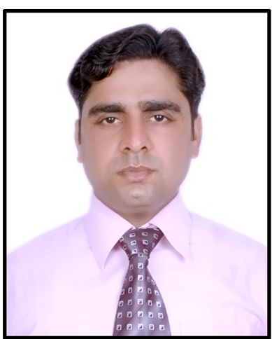
Amit Kumar S/o Mr. D.B.Singh
Pilkhuwa (Sukhlal Ki Mandhiya)
Dist-Hapur (U.P.), India. PIN-245304
Phone: 9821498376
Email: kumar.amit8103@yahoo.com

AMIT KUMAR

11 YEARS OF EXPERIENCE IN Senior Manager-Service (PAN India)
AFTER SALES SERVICE Cummins HHP trained

AIM | To work as a key player in a challenging and creative environment, and build a career with the dedicated people.
EDUCATIONAL QUALIFICATION | - Passed Matriculation from U.P. Board Allahabad in 1998.  - Passed intermediate (10+2) from U.P.Board Allahabad in 2000.
TECHNICAL QUALIFICATION | - B.Tech in Electrical & Electronics Engineering with first division in 2007 from Noida Institute of Engg. & Technology,Greater Noida,U.P. Which is Affiliated to Uttar Pradesh Technical University ,Lucknow, U.P. (India).  - Diploma in Mechanical Engineering with first division in 2003 from Govt.Polytechnic,Ghaziabad,U.P.(India).
EMPLOYER  DURATION  DESIGNATION  PRODUCTS HANDLING  RESPONSIBILITIES/  CAPABILITIES | Escorts Limited. (MNC)  April-2016 to till date.  Product Reliability Manager  Tractors  - Receiving product feedback from field with the help of SCR, FIR & Warranty. Analyzing the concerns and submit to plant QA and resolve query (If any).  - Generate monthly MIS for service concerns and analyzing the same and as per log-in criteria register these service concerns to QA as FSC. This submission is through QPDS supporting with warranty data.  - Monitor the resolution of these FSCs on weekly basis through EAG (Empowered Action Group).  - Monitoring of implemented corrective actions for post modified failures (If any) on monthly basis and sharing the same with QA.  - Conducting a Retro-Fitment drive for the concerns resolved for existing customers.  - Conduct the technical day in the field.
EMPLOYER  DURATION  DESIGNATION  PRODUCTS HANDLING  RESPONSIBILITIES/  CAPABILITIES | Mahindra & Mahindra Ltd.(MNC)  June -2007 to March -2016.  Sr. Manager – Customer Support  Tractors  - Building customer relations.  - Warranty operations.  - Monitoring Mean Time To Restore (MTTR).  - Competency mapping for Service Dealers and planning for their training.  - Periodic audits at Dealership.  - Critical Failure assessment.  - Quality load analysis and solution provider.  - Customer / Quality feedback.  - Overall, responsible for co-ordination and support to field-team to ensure smooth after-sales service support.  - Attend to critical issues which need HO support for understanding and resolution.  - Root Cause Analysis of Critical failures on Engines & Powertrain.  - Skill development, Training & communication to Field Service Engineers on critical failures, settings, operations.  - Accountable to build a team of Experts in key locations for promoting & strengthening tractors sales.  - Liaise with plant to arrive at root cause and take corrective actions & resolve issues at plant.  - Recall & retro fitment management.  - New Product DFS & monitoring of Seeding batches for customer feedback.

COMPUTER PROFICIENCY

- Knowledge of “C” Language.
- Knowledge of SAP.
- PLC Programming.
- Operating system: Words, Excel and Power Point.
- Internet surfing and Basic Knowledge of Computer.

AWARDS AND ACHIVEMENTS

      - “NCC” B Certificate at school level.
      - First prize winner in sports at state level.

STRENGTH
      - Good Communication skills.
      - Adjusting nature.
      - Ability to work in team.
      - Seek to weakness in my work.
      - Positive attitude.
      - Punctuality

PERSONAL PROFILE
Name : Amit Kumar.
Father’s Name : Mr. D.B.Singh.
Date of Birth : 26th Nov .1983.
Gender : Male.
Marital Status : Married.
Nationality : Indian.
Languages Known : English & Hindi.
Hobbies : Teaching, Travelling and Listening to music.
Category : General.

CURRENT LOCATION : Faridabad

NOTICE PERIOD : One month

WILLING TO RELOCATE : Yes

DECLARATION

I hereby declare that the above written particulars are true to the best of my knowledge and belief.

DATE: (AMIT KUMAR)
PLACE:

